Day 24 King David (2 Samuel 1-12): Readings 2 Samuel 1-3, 5-7, 9, 11-12
Overview of 2 Samuel https://www.youtube.com/watch?v=YvoWDXNDJgs (5:56)

2 Samuel: An Outline

I. David becomes King over Judah and Israel (2 Samuel 1:1-5:5)
A. David becomes King over Judah (1:1-2:7)
B. David becomes King over Israel (2:8-5:5)
II. David’s Kingdom Established Forever (5:6-10:19)
A. David makes Jerusalem his Political and Religious Capital (5:6-6:23)
B. God promises David an Everlasting Kingdom (7:1-29)
C. The Military Successes of David’s Reign (8:1-10:19)
III. David’s Sin and its Consequences (11:1-20:26)
A. David’s sin with Bathsheba (11:1-12:31)
B. Trouble with David’s Sons (13:1-14:33)
C. Absalom’s Rebellion (15:1-18:33)
D. David restored to the Throne (19:1-20:26)
IV. Appendix: The LORD as Supreme King over Israel (21:1-24:25)
A. The LORD sends Famine on Israel for Saul’s Sin (21:1-14)
B. David’s Heroes defeat the Philistines (21:15-22)
C. David praises the LORD for his Victories (22:1-51)
D. David’s Final Words (23:1-7)
E. David’s Mighty Men (23:8-39)
F. The LORD sends a Plague on Israel for David’s Sin (24:1-25)
(Based on Accordance “Outlines”)

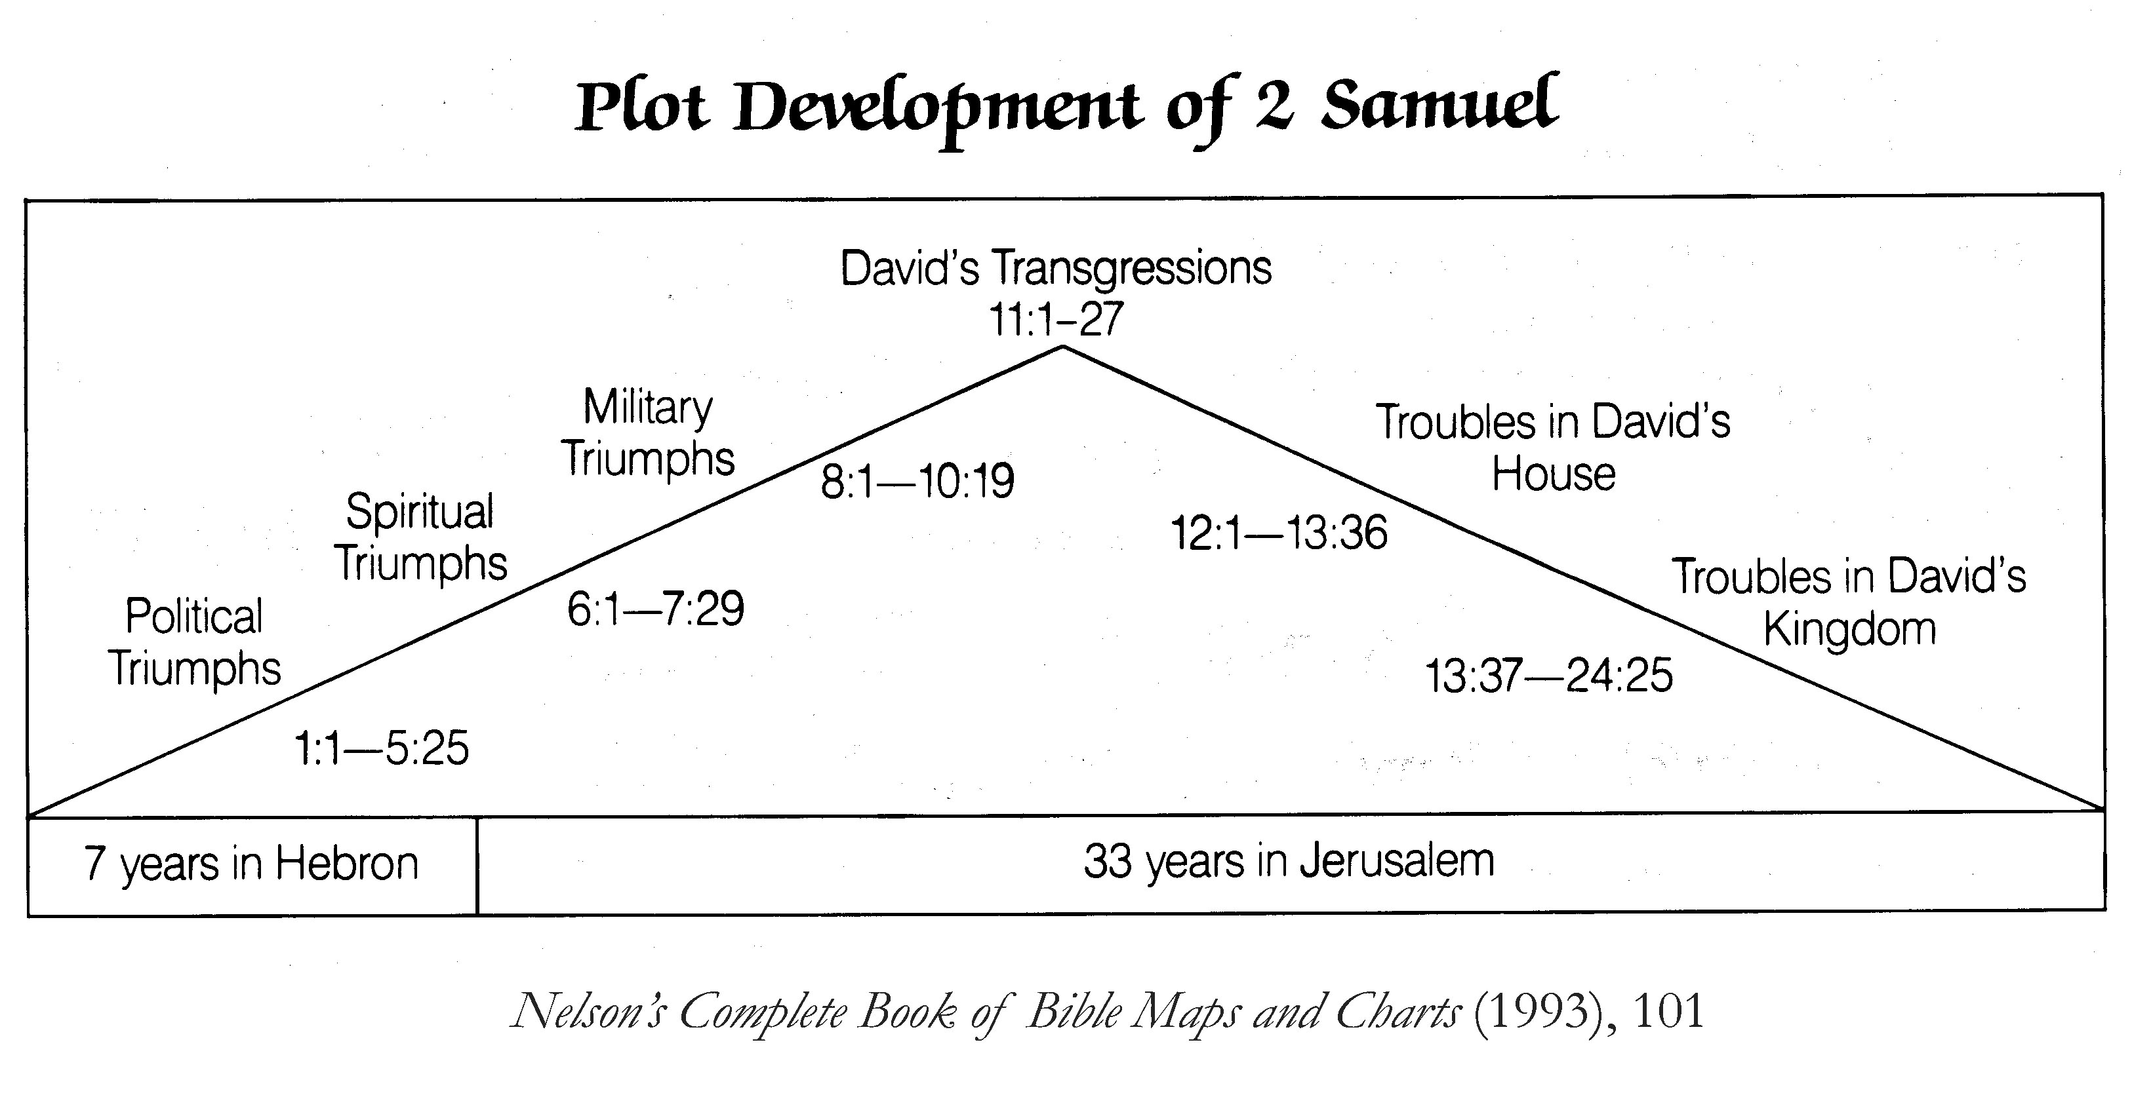

Historical Background of Israel
Several years after David was anointed by Samuel to become king, Saul and three of his sons were killed fighting the Philistines (1 Sam. 31; ca. 1011 B.C.). The tribe of Judah chose David as its ruler. Saul’s general and cousin, Abner, supported Saul’s remaining son Ish-bosheth as a puppet ruler of the northern tribes of Israel, but seven years later David became king of all Israel and captured the city of Jerusalem from the Jebusites, making it his new capital (2 Sam. 1-5). A relative power vacuum in the ancient Near East, coupled with David’s energy and ability and the Lord’s favor, allowed David to expand Israelite control over most of Israel’s neighbors and collect tribute that greatly enriched the kingdom (see Bible Map 4). Jehovah covenanted with David to establish David’s descendants as rulers of Israel forever (2 Sam. 7). David’s posterity did indeed rule in Jerusalem for almost four centuries, but ultimately this promise will be fulfilled in the millennial reign of the Lord (e.g., Isa. 9:7 // 2 Ne. 19:7; Ezek. 37:22-26). The Bible depicts David as a king who was always loyal to Jehovah, whose heart was never swayed to worship other gods; however, there were episodes which tarnished this golden age of Israel, including David’s infidelity with Bathsheba and subsequent complicity in the death of Uriah, and the family problems that plagued the latter portion of his rule, including the rebellion of his son Absalom (2 Sam. 6-24). Just prior to David’s death (ca. 971), the prophet Nathan anointed Solomon as David’s successor (1 Kgs. 1). Solomon, loved of the Lord and noted for his wisdom, built the first Israelite temple to Jehovah in Jerusalem (1 Kgs. 6-8; cf. 2 Ne. 5:16). (This temple stood for more than three and a half centuries until it was destroyed by the Babylonians in 586 B.C.). By the end of his forty-year reign, Solomon encountered political, economic and personal spiritual challenges that he failed to successfully resolve (1 Kgs. 11). …
Dana M. Pike, “Israel, Historical Background of,” in Dennis Largey, ed.,
Book of Mormon Reference Companion (2003), 410.

Almost immediately after the death of Saul, David became king over his own tribe of Judah. Whereas Samuel had anointed David to become king, the men of Judah anointed David in Hebron to be their king (2 Sam 2:4). However, he would have to fight a long and bitter war against Saul’s surviving son Ishbaal/Ish-bosheth and his followers to reunify the kingdom. David assembled an army and successfully fought and defeated Ishbaal/Ish-bosheth, who was killed. Seven years after the death of Saul, David was proclaimed and anointed king over all of Israel, again in Hebron (2 Sam 5:3).

David was a brilliant and effective military leader who reunited Israel after the civil war. He brought peace and security to the kingdom of Israel by establishing treaties with the Philistines. He further created an empire by defeating the Edomites, Moabites, Ammonites, and the nation-states of Aram/Syria, such as Damascus and Zobah, subjecting them to his control all the way to the Euphrates River (2 Sam 8). This is probably intended to signify that David extended his empire to include the boundaries described in the Abrahamic covenant: “from the river of Egypt unto the great river, the river Euphrates” (Gen 15:18).
Holzapfel, Pike, and Seely, Jehovah and the World of the Old Testament (2009), 206.

The Davidic Covenant and the House of David
The biblical description of the covenant made with David seems markedly different from the one Jehovah made with Moses and the Israelites. The Mosaic covenant was based on revealed law, with blessings for obedience and curses for disobedience. Scholars, however, describe the Davidic covenant as a royal grant, modeled on an ancient Near Eastern practice in which a king gifted land or some other favor to a loyal subject. The biblical text gives little evidence that David, having already proved his loyalty to Jehovah, had to do more than accept God’s seemingly unconditional gift of kingship.
The text of 2 Samuel 7 contains the biblical report of what Jehovah promised David. This chapter presents a wonderful play on the multifunctional Hebrew word bayit, “house” (bayit becomes beth when grammatically linked to a following noun). Having consolidated political and religious power in Jerusalem, and having already built his bayit, meaning his “palace” (2 Sam 7:1-2), David wanted to build a Temple to the Lord. The common Hebrew word for “temple” is bayit/beth. Jehovah rhetorically asked David through the prophet Nathan, “Shalt thou build me an house [bayit] for me to dwell in?” (2 Sam 7:5). Instead, the Lord promised, “the Lord telleth thee that he will make thee an house [bayit]” (2 Sam 7:11), which in this context means “dynasty, posterity.” The “house of David” was the dynastic title of David’s descendants for more than 350 years. It occurs in the Bible (e.g., 1 Kgs 12:19; 2 Chr 21:7), as well as in the Tel Dan Inscription. …
The rest of 2 Samuel 7 expands on this dynastic promise as Jehovah further declares to David: “I will set up thy seed after thee … and I will establish his kingdom. He [Solomon] shall build an house [bayit; temple] for my name, and I will stablish the throne of his kingdom for ever” (2 Sam 7:12–13). Furthermore, using language also found in other ancient Near Eastern texts, Jehovah declared, “I will be his father, and he shall be my son. If he commit iniquity, I will chasten him … [but] my mercy shall not depart away from him. … And thine house [bethka; dynasty] and thy kingdom shall be established for ever” (2 Sam 7:14-16; see also 7:25-29). Psalm 89:3-4 reiterates this seemingly unqualified promise. However, Psalm 132:12 presents a qualification: “If thy children will keep my covenant … their children shall also sit upon thy throne for evermore.”
Historically, David’s descendants through Solomon reigned in Jerusalem, but the kingdom was divided at Solomon’s death, so his posterity ruled only Judah, not all Israel. And by 586 BC the kingdom of Judah ceased to exist. Many Christians understand the “forever” part of Jehovah’s covenant with David to be fulfilled by Jesus, who descended in the flesh from David (Rom 1:3) and who rules for all eternity.
Gabriel promised Mary that Jesus “shall be called the Son of the Highest, and the Lord God shall give unto him the throne of his father David” (Luke 1:32). And Jesus testified, “I am the root and the offspring of David” (Rev 22:16).
Holzapfel, Pike, and Seely, Jehovah and the World of the Old Testament (2009), 207.

David’s success as king are presented in 2 Samuel 5-9. They include his conquests and his establishment of Jerusalem as the new capital city. This was crowned by bringing the ark of the covenant out of exile and placing it back in operation. It should not be thought coincidental that this was followed immediately by the formation of the Davidic covenant, which stood as the charter for the new Era. Thus in chapter 6 David reestablished the throne of Yahweh (i.e. the ark), while in chapter 7 Yahweh established the throne of David. The Davidic covenant was the centerpiece of the narrator’s agenda. Everything in the narrative up to this point had been moving in this direction. From here on in the narrative, everything is to be understood in light of this covenant.”
Hill & Walton Survey of the Old Testament 267

Ark of the Covenant
“The judges period ended in exile of sort—a self-imposed exile of the Lord represented in the ark of the covenant’s being captured by the Philistines and taken out of the land of Israel. . . .The fact that the ark had been captured would have naturally led to the conclusion that the Philistine god, Dagon, was more powerful than the Israelite God, Yahweh. The events in chapters 5-6 are reported to dispel any such idea. With Yahweh’s demonstration of his power over the idol of Dagon and also his plague on the Philistine people, it became clear that the Lord had not been overpowered, but had rejected and therefore abandoned the Israelites. The theme of divine abandonment is well-known in the ancient Near East. This self-imposed exile marked a distinct break between the period of the judges and the monarchy. The account of the return of the ark from exile uses language that is reminiscent of the exodus. It is of theological interest that the ark’s temporary housing continued throughout all of Saul’s reign and that the ark was not officially brought back into prominence until David brought it to Jerusalem (2 Sam 6). This suggests that both Samuel and Saul were transitional figures.”
Hill & Walton Survey of the Old Testament 261

Jerusalem
Jerusalem is also known in the Old Testament as Salem, the City of David, Mount Zion, or simply Zion. In later Jewish tradition it was known as the “City of Peace” (Heb 7:2). Jerusalem sits about 2,500 feet above sea level on a ridge that runs through the central mountain range of the country. The earliest known area of the city, the City of David, was located on the lower end of the Ophel, a ridge sloping south from the Temple Mount. . . . Typically this area is cool and rainy during the winter months (December through March). Snow falls almost every year, but melts quickly. During the summer months the climate is temperate and dry.
Jerusalem was a Jebusite city long before David made it an Israelite city. The name Jerusalem occurs as “Rushalimum” in the Egyptian Execration Texts (nineteenth to eighteenth centuries B.C.) and as “Urusalim” in the Amarna Letters (fourteenth century B.C). In the Bible Jerusalem is first mentioned in Genesis 14: “And Melchizedek king of Salem brought forth bread and wine: and he was the priest of the most high God” (Gen 14:18). Shortly thereafter, Abraham went to the “land of Moriah” to sacrifice his son Isaac (Gen 22:2). According to biblical tradition the hill where Abraham offered Isaac is identified with Mount Moriah, in Jerusalem, where Solomon’s Temple would later be built (2 Chr 3:1).
The city is next mentioned in the book of Joshua: “And the border [of the territory of Judah] went up by the valley of the son of Hinnom unto the south side of the Jebusite; the same is Jerusalem: and the border went up to the top of the mountain that lieth before the valley of Hinnon westward, which is at the end of the valley of the giants northward” (Josh 15:8).
In about 1000 B.C., David captured the small but strongly defended city and made it the religious and political capital of his kingdom (2 Sam 5; 6). When David took the city, it was home to about two thousand inhabitants living in a walled-in, twelve-acre area. Most likely David chose Jerusalem for his capital because it was located in the neutral territory between the territories allotted to Judah and Benjamin.
Additionally the city had access to an abundance of water from the Gihon spring and was situated on a hill, surrounded on three sides by deep valleys, making it easier to defend. David brought the ark of the covenant into the city, making it the undisputed capital of all twelve tribes (2 Sam 6). He also built a palace (2 Sam 5:11), remnants of which some believe may have been discovered by archaeologists in 2005.
Later, Solomon expanded the city northward where he began to build the Temple about 964 B.C. (1 Kings 6-7). By this time, the city may have reached about five thousand inhabitants in a walled-in area as large as thirty-two acres—more than doubling the size of the original Jebusite city captured by his father David.
In the eighth century B.C., Hezekiah expanded the city westward to include what today is known as Mount Zion. The significant increase in population at that time was presumably due in part to the arrival of thousands of refugees fleeing the northern kingdom in the face of the Assyrian advance. In addition to new and reinforced walls. Hezekiah secured access to the Gihon spring through his famous tunnel in preparation for the Assyrian assault on the city. The Assyrian army invaded Judah in 701 B.C. and destroyed most of its cities. Jerusalem was miraculously preserved when the Assyrian army was destroyed at the gates of Jerusalem by an “angel of the Lord (2 Kgs 19:35-37). The city survived until the next superpower, the Babylonians, under Nebuchadnezzar, invaded and destroyed the city and the Temple in 586 BC and took many of the Judahites into exile. The destruction of Jerusalem was prophesied and lamented by the prophets for Israel’s breach of the covenant. Isaiah, Jeremiah, and Ezekiel all prophesied the future rebuilding of Jerusalem and the Temple.
Jerusalem was eventually rebuilt by exiles who first returned from Babylon beginning in 538 B.C. They rebuilt the Temple by 515 B.C., but the city walls were not rebuilt until the time of Nehemiah in the fifth century. Under Persian rule Jerusalem continued to be the spiritual center of the Jews. It eventually grew to be a very large and thriving city during the Hasmonean and Roman periods until its destruction by the Romans in A.D. 70.
Holzapfel, Pike, and Seely, Jehovah and the World of the Old Testament (2009), 209.

The Population of Jerusalem in Antiquity

Based on data from archaeological excavations, scholars have determined that the population density of ancient Near Eastern cities was about 160 to 200 people per square acre. From this figure scholars have made estimates of the population of Jerusalem through the years based on archaeological evidence indicating its size. The following are the figures of the estimated population of Jerusalem, based on calculations by Magen Broshi (Biblical Archaeology Review 4/2 [1978] 12) at various times during the biblical period.

Period Area (Acres) Population

1000 BC, Jebusites > King David 12 2,000
928 BC, King Solomon 32 5,000
701 BC, King Hezekiah 125 25,000
450 BC, Nehemiah 30 4,500
150 BC, Hasmoneans 165 30,000
4 BC, Herod the Great 230 40,000
AD 66, Jews revolt against Rome 450 80,000

Holzapfel, Pike, and Seely, Jehovah and the World of the Old Testament (2009), 209.

